Annex “A”
LIBRARY FURNITURES AND FIXTURES

- 4 pcs. Low Computer Table
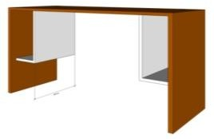
Dimension: L 1400mm x W 500mm x H 750mm
Marine plyboard in semi gloss ducco finish- 2 pcs grommet.

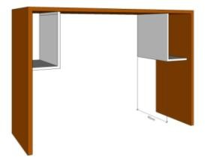
- 4 pcs. High Computer Table

Dimension: L 1400mm x W 500mm x H 1100mm
Marine plyboard in semi gloss ducco finish. 2 pcs grommet.

- 4 pcs. Lounge Seat 1
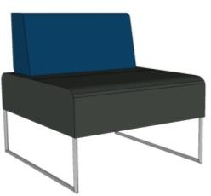
Dimension: L 660 mm x W 750 mm x SH 450 mm x H 775 mm. Cushion seat and backrest on leatherette finish. Powder coated tubular metal legs.

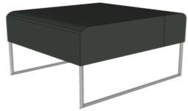
- 1 set Ottoman 1 (4pcs)

Dimension: L 660 mm x W 750 mm x SH 450 mm. Cushion seat on leatherette finish.
Powder coated tubular metal legs.

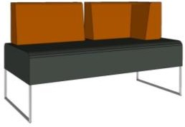
- 2 pcs. Lounge Seat 2

Dimension: L 1785 mm x W 750 mm x SH 450 mm x H 775 mm .Cushion seat and backrest on leatherette finish. Powder coated tubular metal legs.
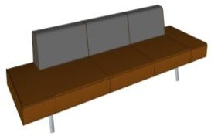
- 2 pcs. Lounge Seat 3

Dimension: L 3045 mm x W 835 mm x SH 450 mm x H 775 mm .Cushion seat and backrest on leatherette finish. Powder coated tubular metal legs.

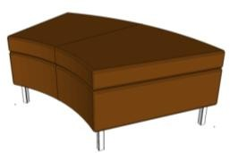
- 3 pcs. Ottoman 2

Dimension: L 1190 x 685mm x W 600 mm x SH 450 mm.Cushion seat on leatherette finish. Powder coated tubular metal legs.

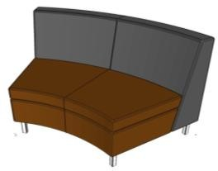
- 3 pcs. Lounge Seat 4

Dimension: L 1190 x 685mm x W 600 mm x SH 450 mm x TH 765 mm.Cushion seat and backrest on leatherette finish. Powder coated tubular metal legs.

- 4 pcs. Lounge Seat 5
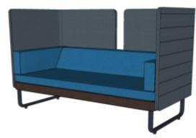
Dimension: L 15250 x W 735 mm x SH 450 mm x TH 1240 mm.Cushion seat backrest and divider leatherette finish. Powder coated tubular metal legs.

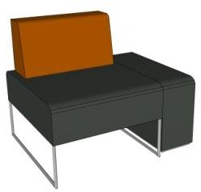
- 2 pcs. Lounge Seat 6

Dimension: L 800 mm x W 750 mm x SH 450 mm x H 775 mm Cushion seat and backrest on leatherette finish. Powder coated tubular metal legs.

- 1 set Small Pebbles (12pcs)
Dimension: W 850 mm x D 700 mm x SH 450 mm. cushioned seat in leatherette finish, Color: blue(4), yellow(4) and grey (4)
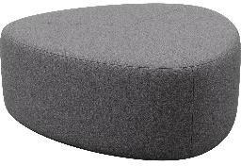

- 1 set Medium Peebles (7pcs)

Dimension: W 1200 mm x D 1100 mm x SH 450 mm. cushioned seat in leatherette finish, Color: blue (3), yellow (3) and grey (3)

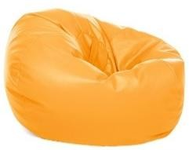
- 1 set Beanbag (4pcs)

Specs: medium leatherette bean bag –dark blue

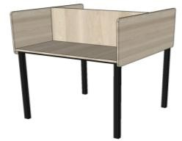
- 1 set Study Carrel (12pcs)

Dimension: L 785 mm x W 800mm X H 750mm x 400mm. table top and divider in marine plyboard on laminate finish.
Powder coated tubular metal legs

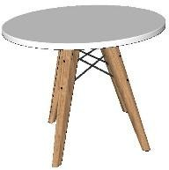
- 1 set Round Table (6pcs)

Dimension: Dia. 800mm x 750 mm ABS Plastic top. Wood base

- 1 set Rectangular Coffee Table (4pcs)

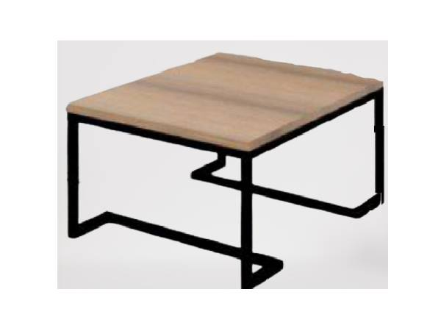

Dimension: L 1000mm x W 500 mm x H 450 mm. MDF (12)
with Melamine table top. Black metal tube sandy powder coating
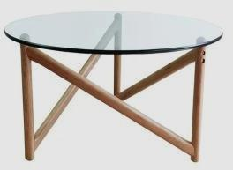
- 1 set Round Coffee Table 1 (3pcs)
Dimension: Dia. 750mm x H 435mm.
Top: Clear Glass Base: Natural
• - 12mm thick tempered glass with 33mm dia Solid Oak wood table base in clear lacquered finish.
- 25mm dia Rubber vacuum glass holder.

- 1 set Round Coffee Table 2 (2pcs)
Dimension: 1300mm dia x 350 mm. Glass table top w/ chrome metal legs

- 1 set Lounge Accent Chair (4pcs)
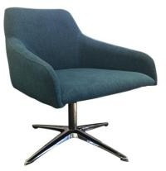

Cushion chair w/ metal swivel legs

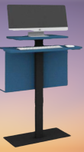
- 3 pcs. OPAC

Specs: powder coated metal computer compartment –blue color
Total length of the neck (from the keyboard base) is 11.5”
Total length of the steel bar is 34”, from the keyboard base to the top of the cabinet is 3.5”, from the bottom of the cabinet to top of the base is 4.5”

- 1 pc. Conference Table

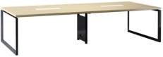

Dimension: W 1400mm x L 3200 mm x H 750 mm.
Melamine panel table top with powder coated metal legs

- 4 pcs. Staff table
* Office table: 160 x 80 x 75cm with drawer and side cabinet/mobile pedestal, melamine finish with pvc edging and wire mechanism set

- 1 set Glass top reception desk (2 pcs.)
Color: Dark Grey & Parchment White;
Materials:18mm particle board with melamine finish
Edges banding: Impact-resistant PVC,2mm for table top,0.8mm for other panels
Well-organized wire grommets on top
One standard office desk and one mobile B/B/F pedestal for options
- 2 pcs. White Board

Dimension: 1500 mm x 1000 mm back painted glass

